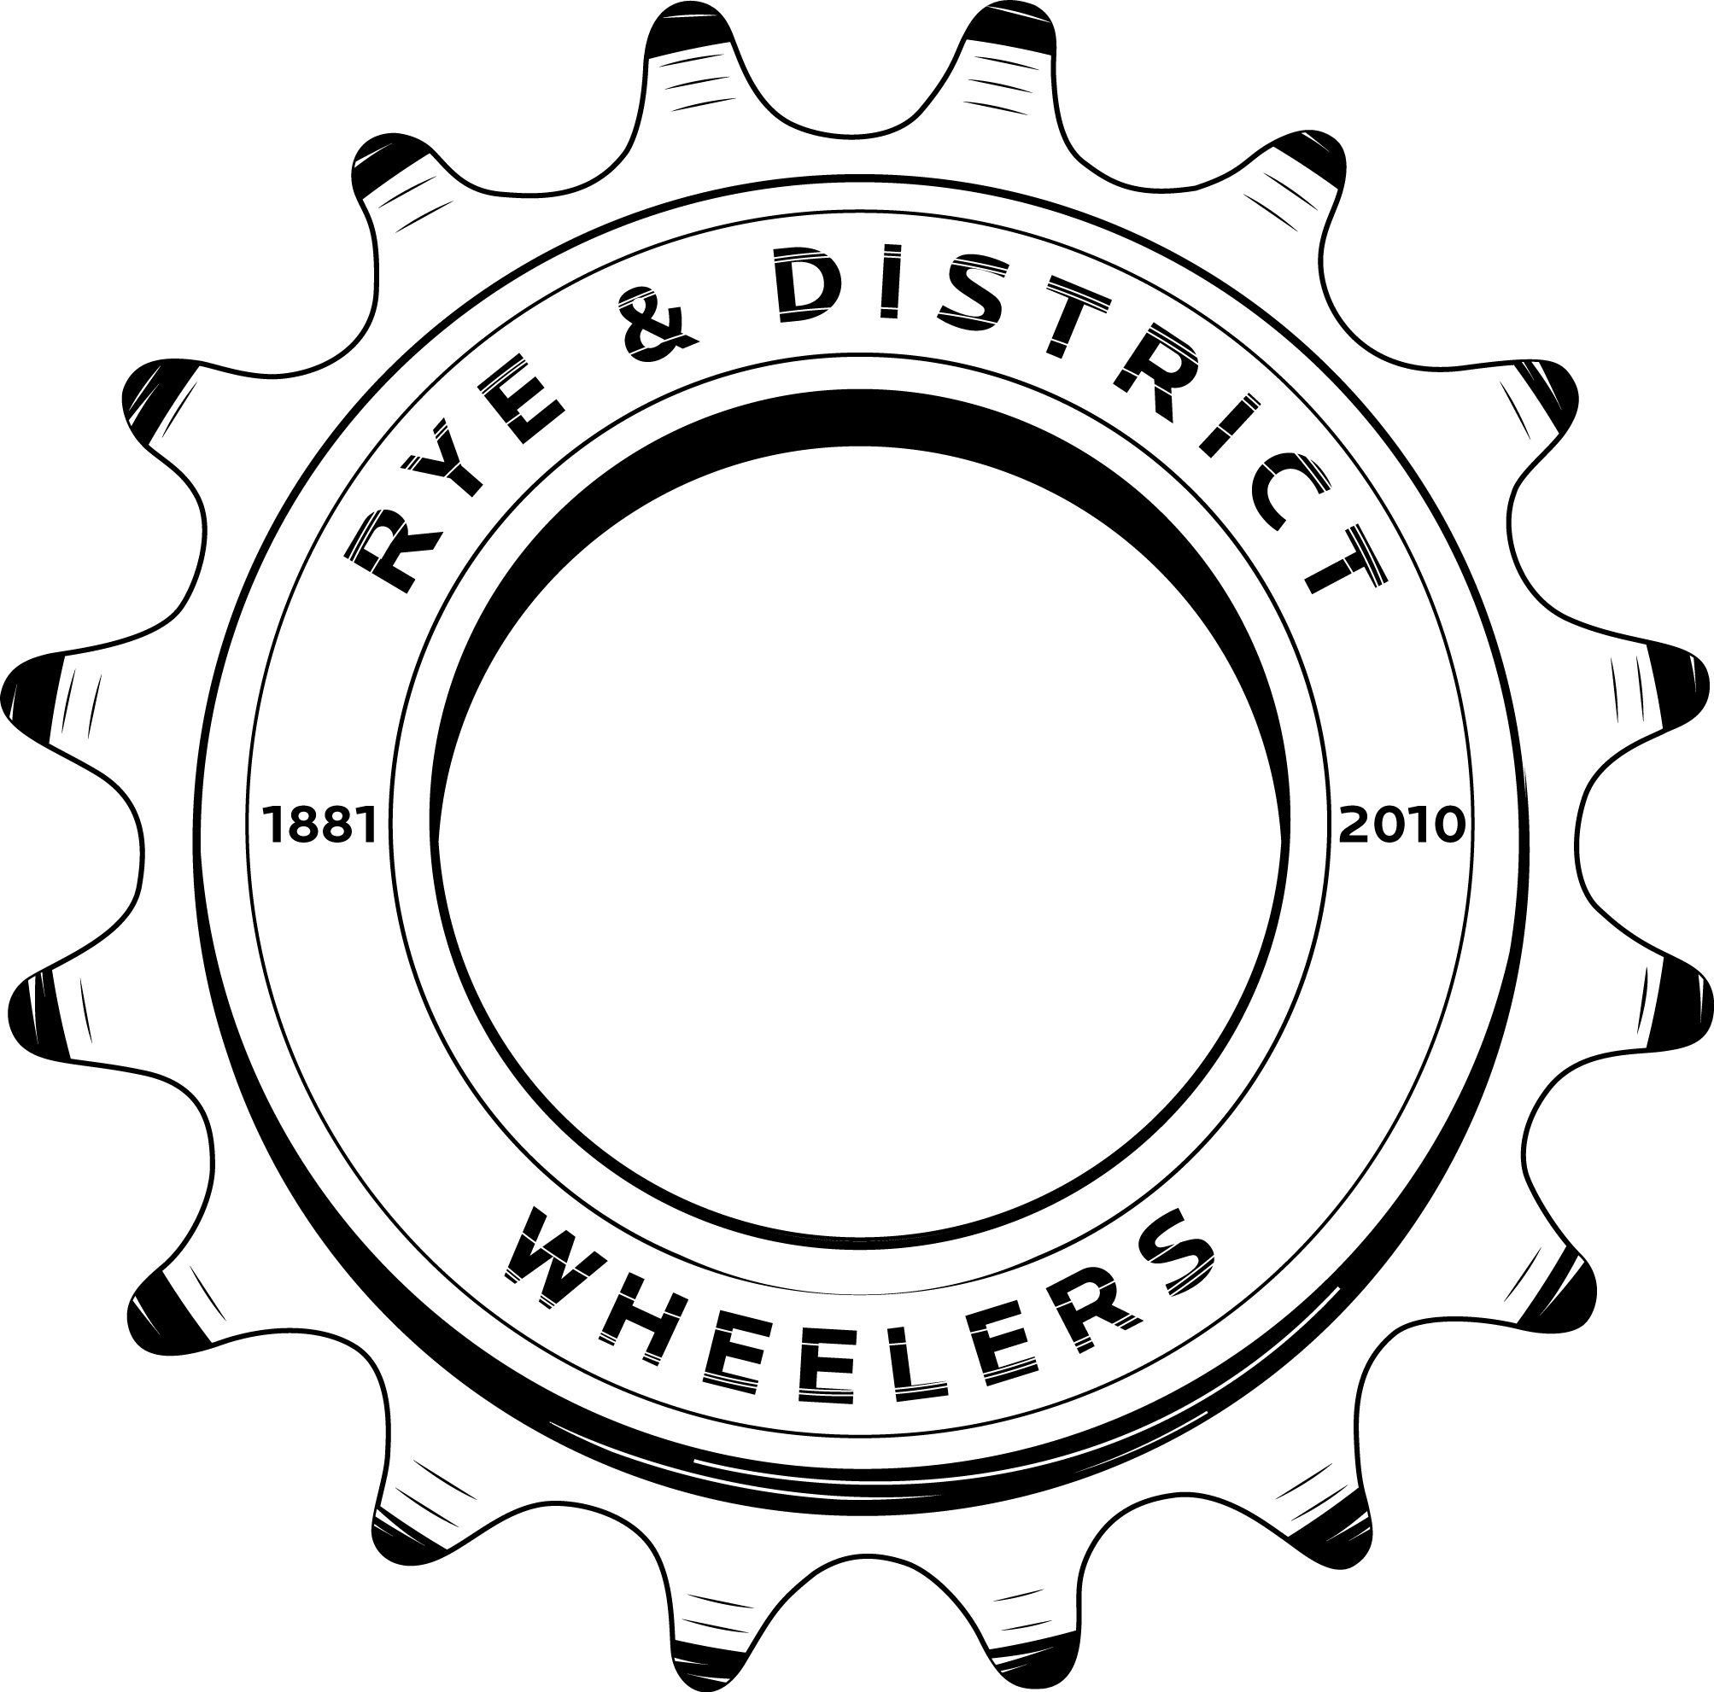

The Design
2010 was a landmark for Rye & District Wheelers in that it marked the tenth anniversary of the Club reforming in 2000. A new kit design was therefore adopted to commemorate this anniversary whilst celebrating the Wheelers' long and illustrious history as arguably the first cycling club ever formed.
The kit design is a combination of classic, retro and modern elements. The predominantly White shirt with horizontal stripes harks back to the glory days when the likes of messers Hollands, Harrow, Page and the Ashdown clan used to dominate grass track meetings. However the Club's name is presented in lettering which is decidedly 21st century.
The shorts are traditional black but with the Club's web address emblazoned across the seat.
The shirt collar and sleeves also carry a subtle reference to the club's heritage with the year of the Club's original formation (1881) written in script together with the initials R&DW which emphasise the club's full name and the fact that the membership is drawn from Rye and the surrounding district.
The shirt also sports an updated version of the Club badge. Still a sixteen tooth sprocket, the new badge also carries the date of the Club's formation and the recent anniversary.
The kit's blend of traditional and modern, together with the overall clean look and feel are a distinctive departure from the busy designs of many cycling kits and demonstrates the Club's pride in retaining its unsponsored status.
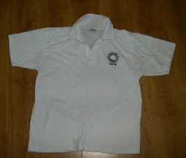

The Choices
The Club also has a range of casual wear, namely Polo Shirts and Hoodies.
These are available in White with Black Logo or Black with White Logo.
Polo Shirts are £9.18 each inc VAT.
Hoodies are £16.08 each inc VAT.

If you are interested please let Paul Simpson know.
paul.simpson21@btopenworld.com
07805 353630

